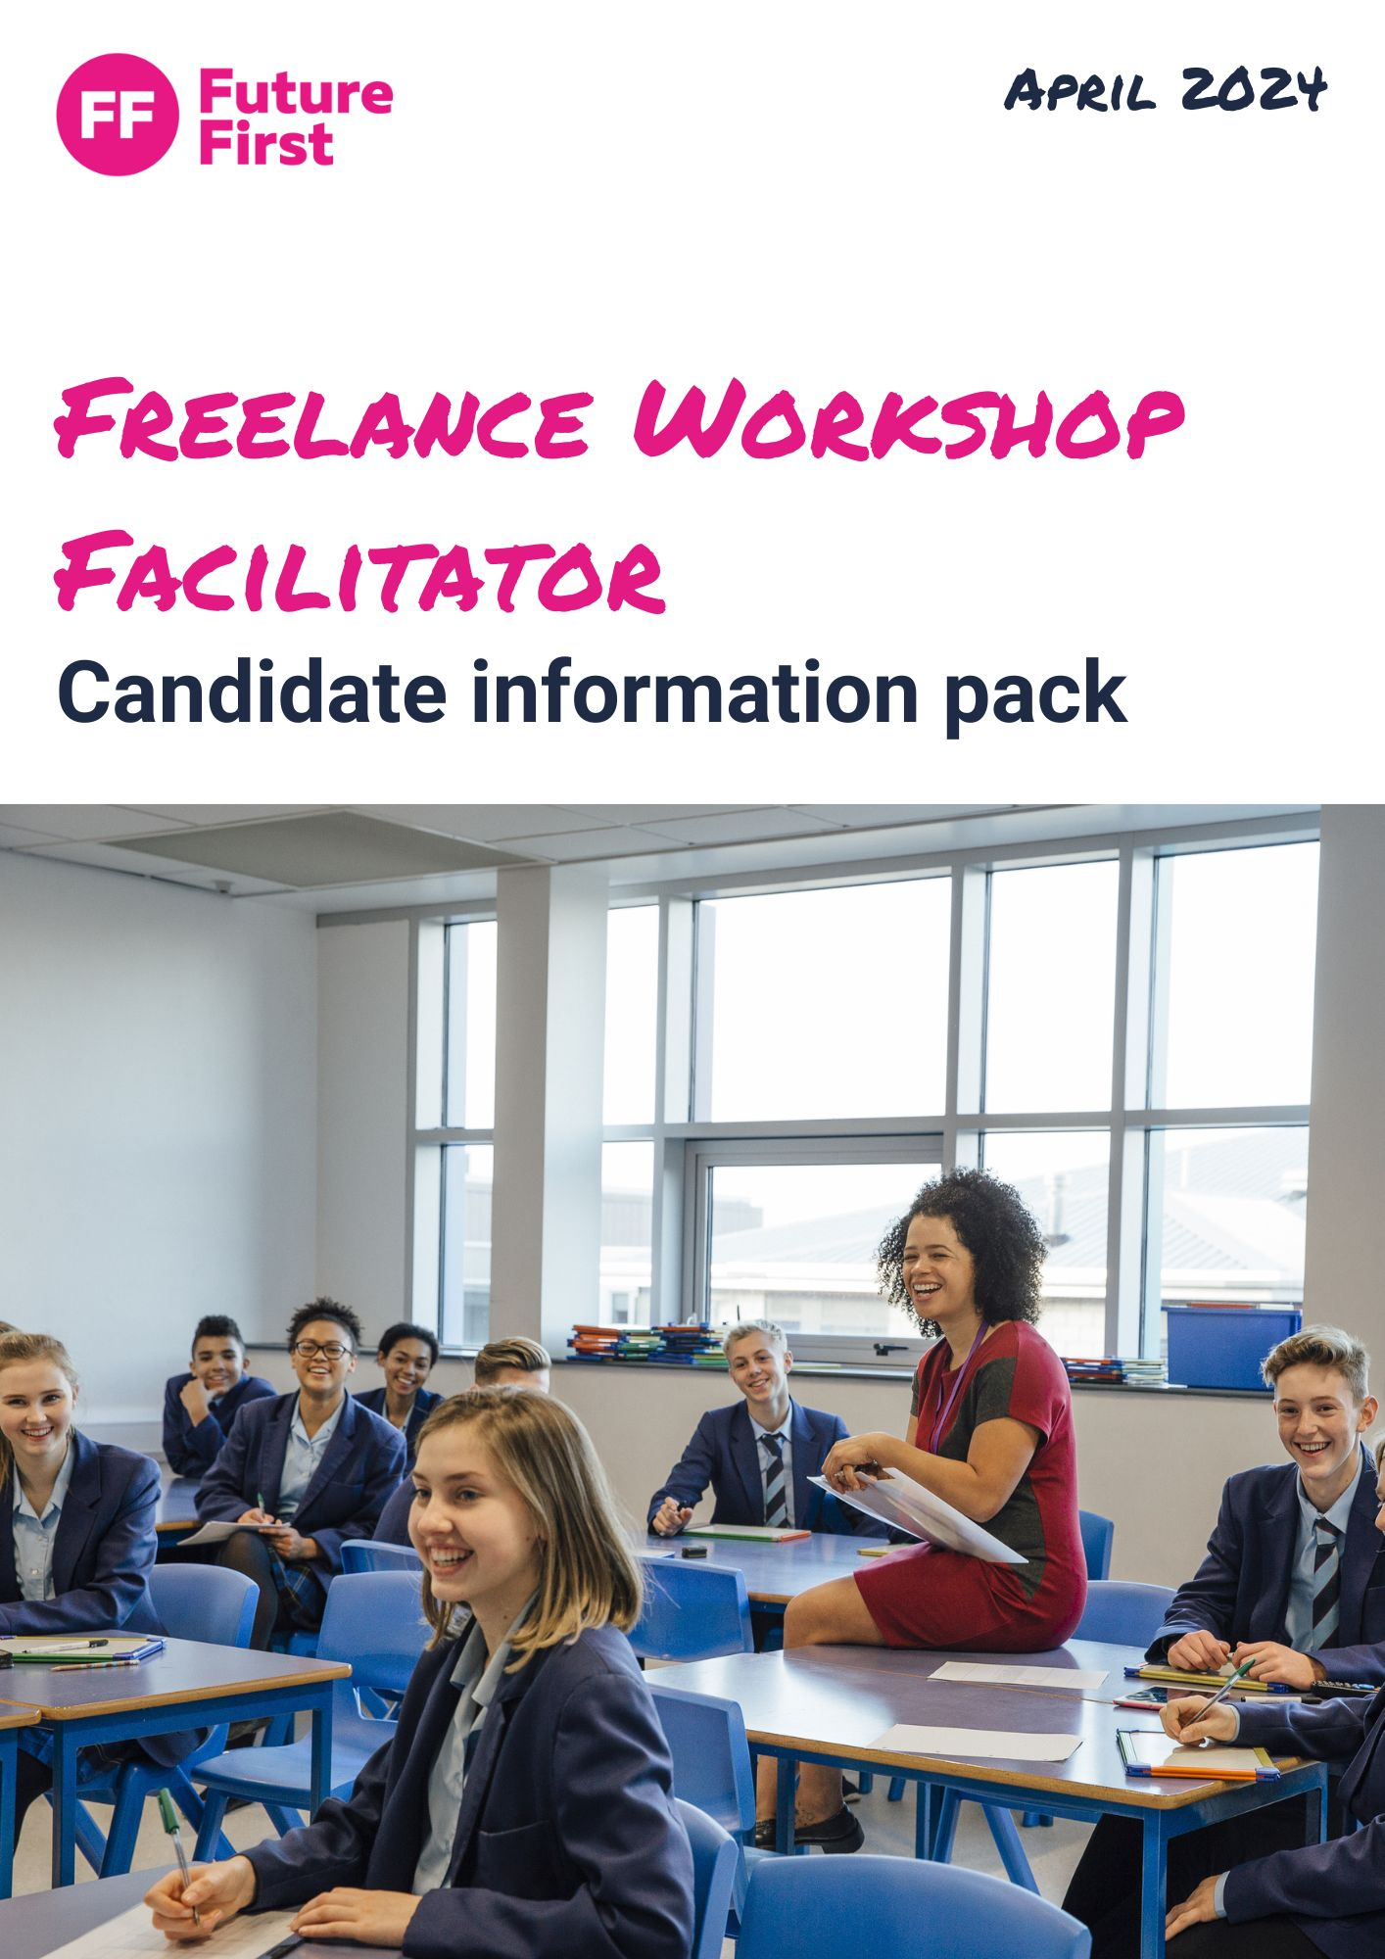

Freelance workshop facilitator

Reports to | Head of membership
Location | National. We are particularly interested in individuals based in the following locations: London, Midlands, South Wales
Salary and expenses | £200 day rate with reasonable expenses agreed in advance
Schedule: | Our workshops occupy a full school day, usually taking place between 8am and  3pm (not including travel).

Future First wants to see every state school and college in the UK, and every state pupil, supported by a thriving and engaged alumni community, which improves students’ motivation, confidence and life chances. We have a network of alumni who have supported our programmes in schools for over a decade. They act as accessible and inspirational role models by sharing their stories through a variety of activities, including blogging, online mentoring, networking and careers activities in schools.

About the role
We are seeking Freelance Workshop Facilitators to support the delivery of our workshops in schools and colleges at busy times of the year. We are looking for individuals with at least one year’s experience working with schools and young people, and who have an engaging facilitation style. Some experience of working with volunteers is preferred.

Key Duties and responsibilities
You’ll lead sessions that support volunteers from the working world to share their advice and expertise with young people aged 11 – 18, enabling young people to grow their confidence, knowledge and motivation. You’ll be responsible for:

- As part of our commitment to the continuing professional development of our freelancers, we ask you to commit to up to 4 hours online training each year. This ensures national QA. This is a great opportunity to develop your facilitating skills and network with other freelancers. In return, we commit to regularly contact our freelancers with delivery session dates. A one off payment of £100 is made to freelancers on the completion of training each year and who then go on to deliver for us.
- First class facilitation which engages all young people during the delivery of workshops
- Delivering impactful workshops, careers events and other activities – using alumni (former students of the school or college) and other volunteers to help students understand the range of career options available to them
- Maintaining regular contact with both Future First and our member schools via email and phone; ensuring that they have the support, materials and practical help that they need to make the most of each session
- Managing the volunteer experience by encouraging them to join activities within the school, preparing them in advance of their attendance (with a short phone call to each volunteer the night before the session) and ensuring they feel supported on the day.

Person specification

Experience and Knowledge | Essential | Desirable
1.Experience of working with young people  2. Experience of managing volunteers  3. Knowledge and experience of the education sector  4. Experience of sometimes dealing with challenging behaviour | X  X  X | X

Skills | Essential | Desirable
1. Confident at engaging and communicating with large groups of students  2. An understanding of the best ways to communicate with young people | X  X

Attributes | Essential | Desirable
1. A high energy, inspiring facilitation style which quickly engages an audience  2. Capable of remaining calm and effective under pressure  3. A flexible approach and willingness to travel to schools and colleges to delivery workshops  3. Full clean driving license | X  X  X | X

How to apply
Please apply by sending a CV and covering letter outlining why you think you are a good fit for the role to recruitment@futurefirst.org.uk.

Application deadline: We will be shortlisting and interviewing on a rolling basis, so please submit applications as soon as possible to avoid disappointment.

Interview: Interviews will take place on Zoom and will be approximately 45 minutes long. Shortlisted candidates will be contacted to agree an interview time. You will be asked to prepare a five-minute presentation if accepted to interview.

At Future First we are committed to social justice and the value of role models. We value and celebrate people’s diversity and believe this strengthens our team and our work. We are keen to build a workforce that reflects the young people and schools we support. We therefore particularly welcome applications from Black, Asian and Minority Ethnic candidates, and those who attended state school and were in receipt of free school meals and/or were the first in their family to go to university.

For questions about the role, please email recruitment@futurefirst.org.uk

